PROJECT SUMMARY

petOnly enterprise is a platform bringing together pet Owner and services for pets.

Owner can see users in the system and requests of the users.

Pet owner add pets to the system and add requests for pet walking, pet grooming and so on.

Used Technologies:

Angular.js

HTML5

CSS

AJAX

Bootstrap

JSON

XML

SCREENSHOTS AND THINGS I HAVE DONE

Homepage.

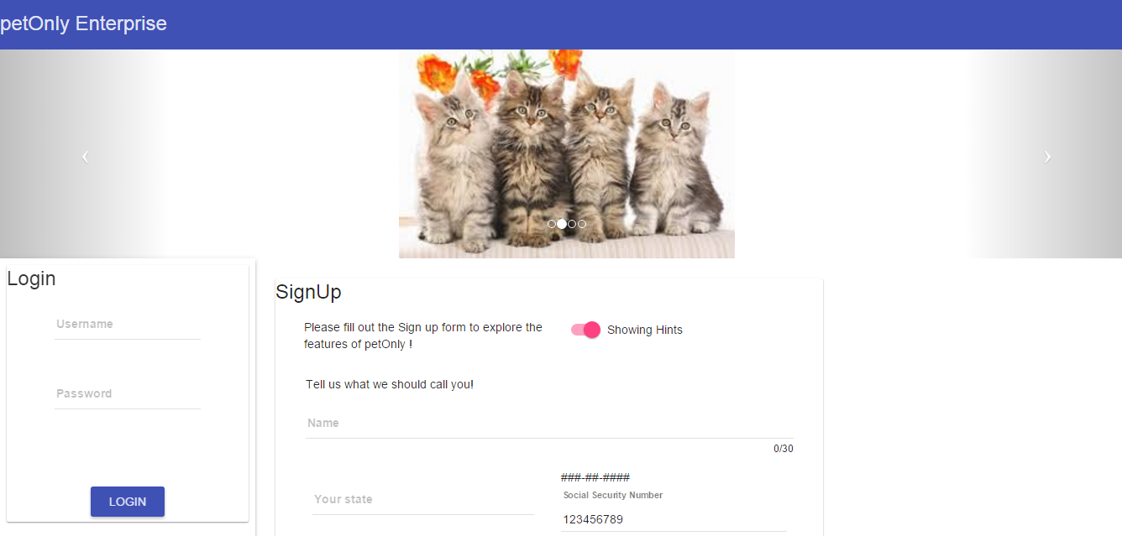

Sign up form with autosuggest

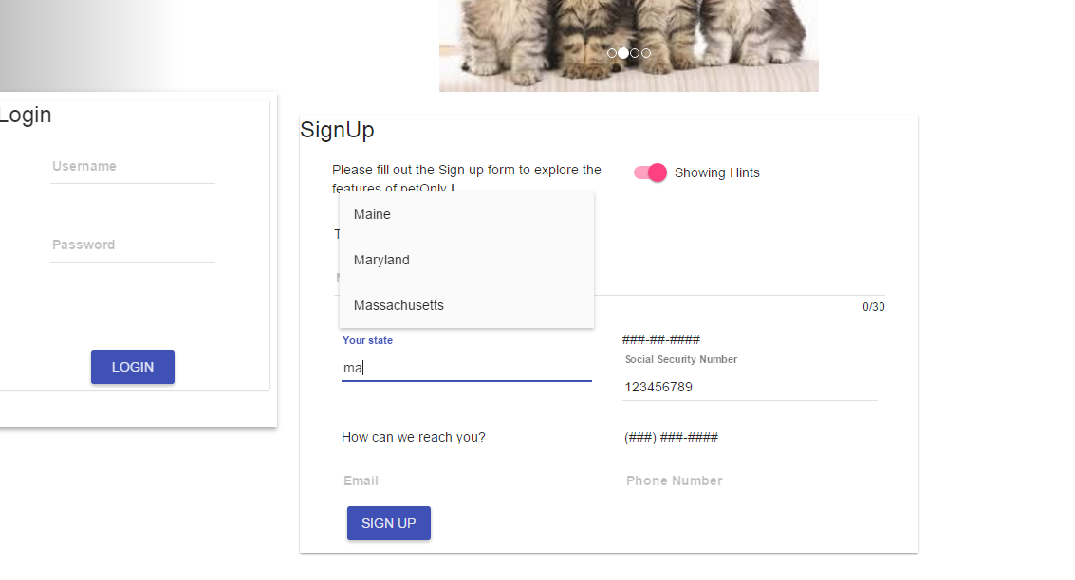

Validations on Sign up Form

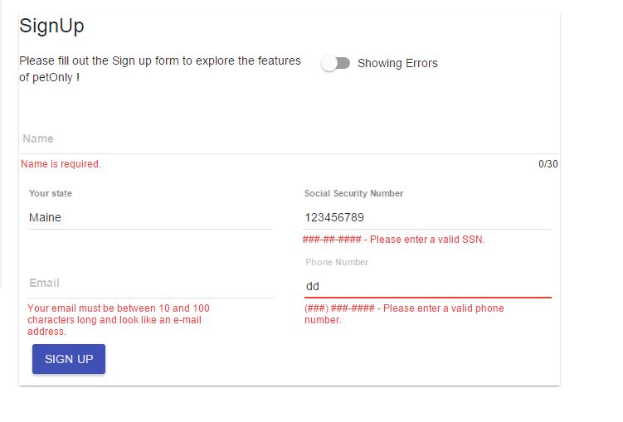

Admin Login

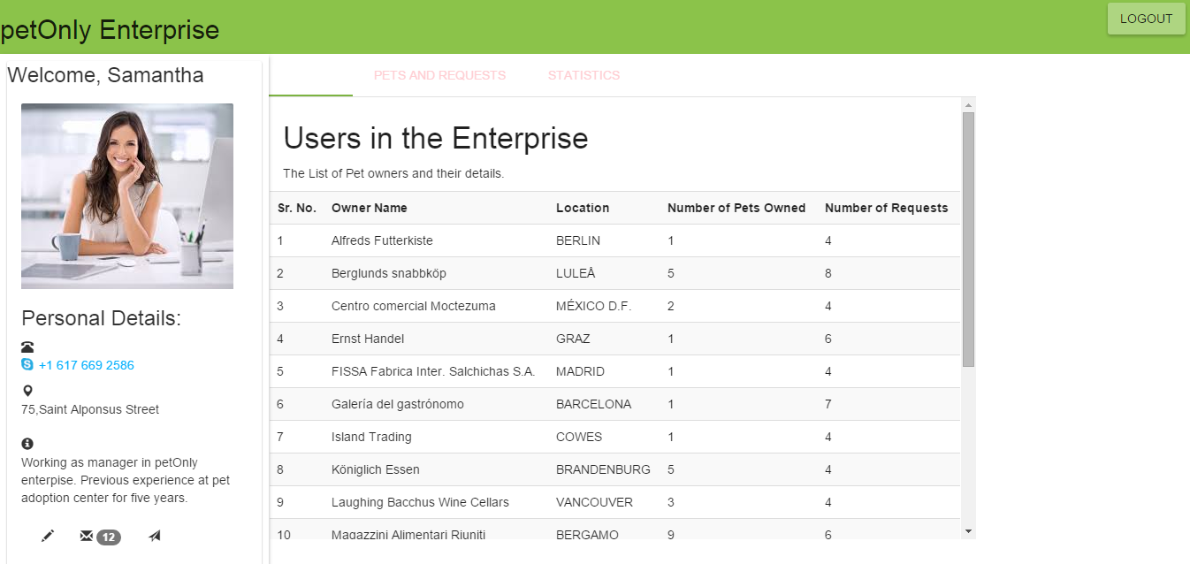

Graph by d3.js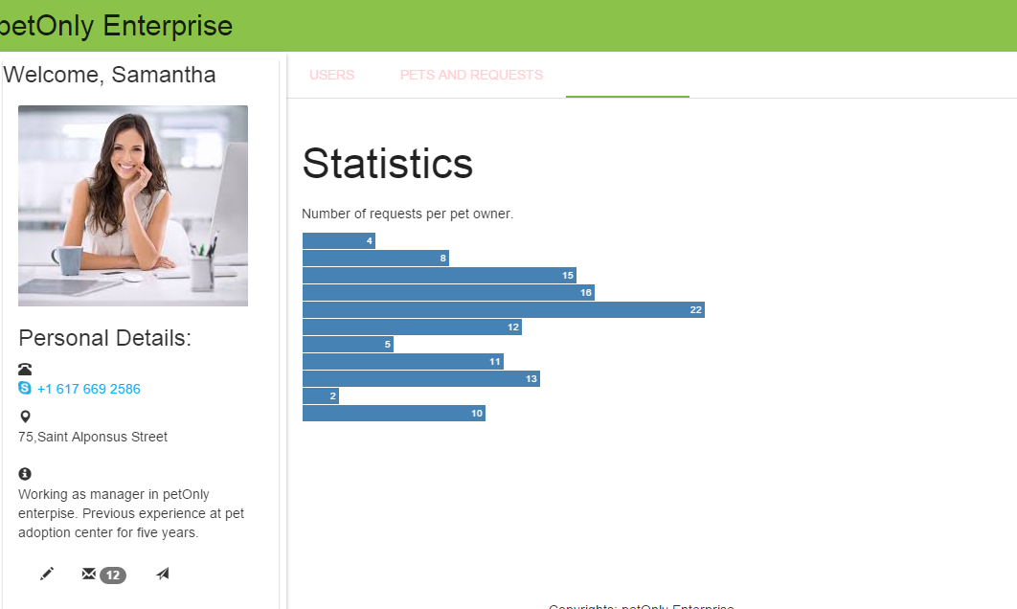

Requests table by AJAX

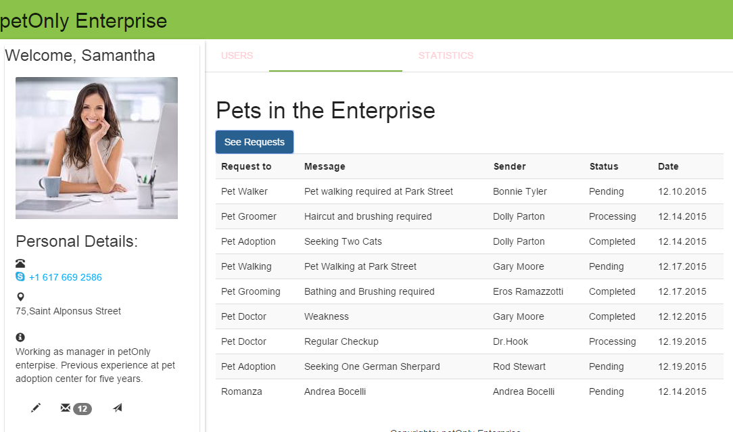

Messages by toggle

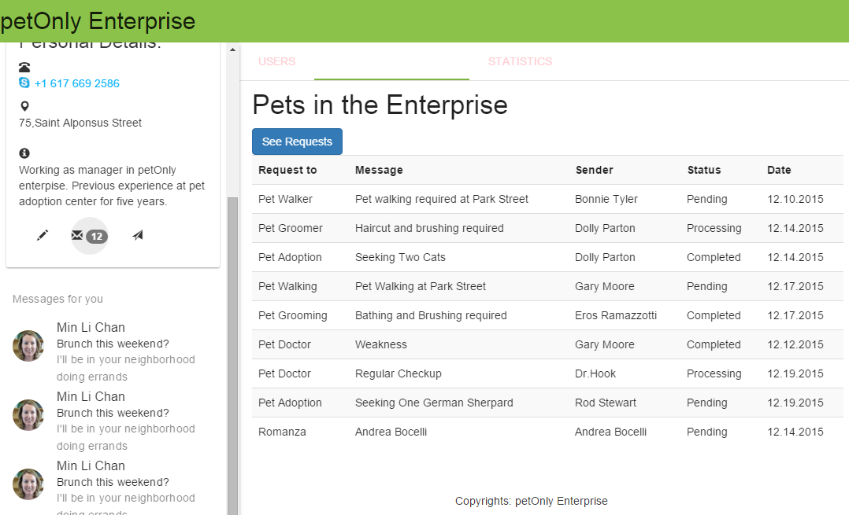

Bootstrap modal

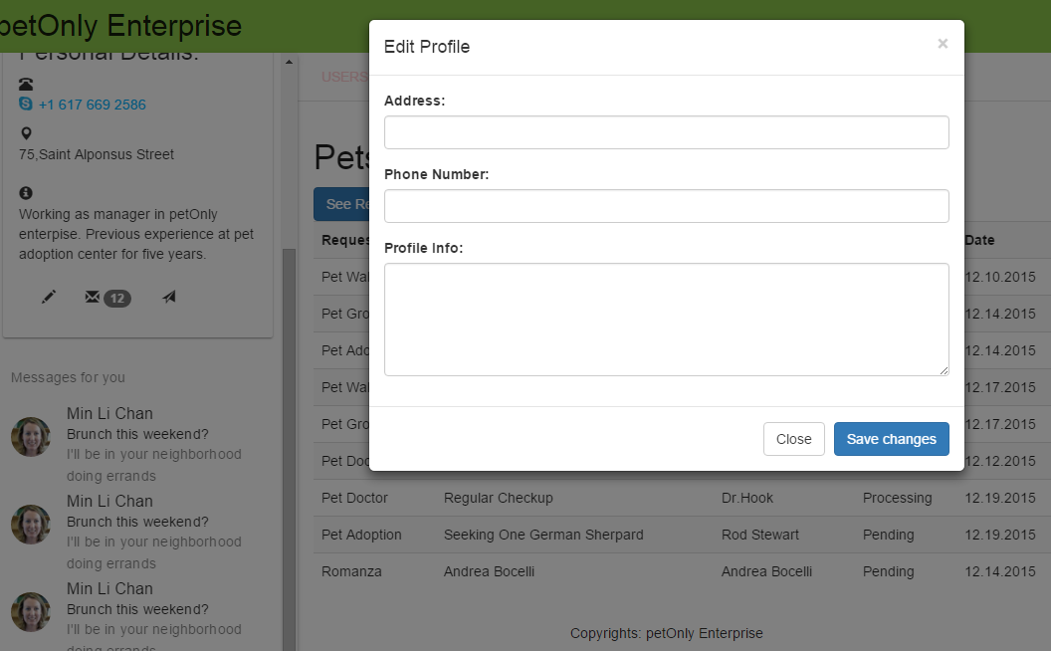

Pet Owner Login

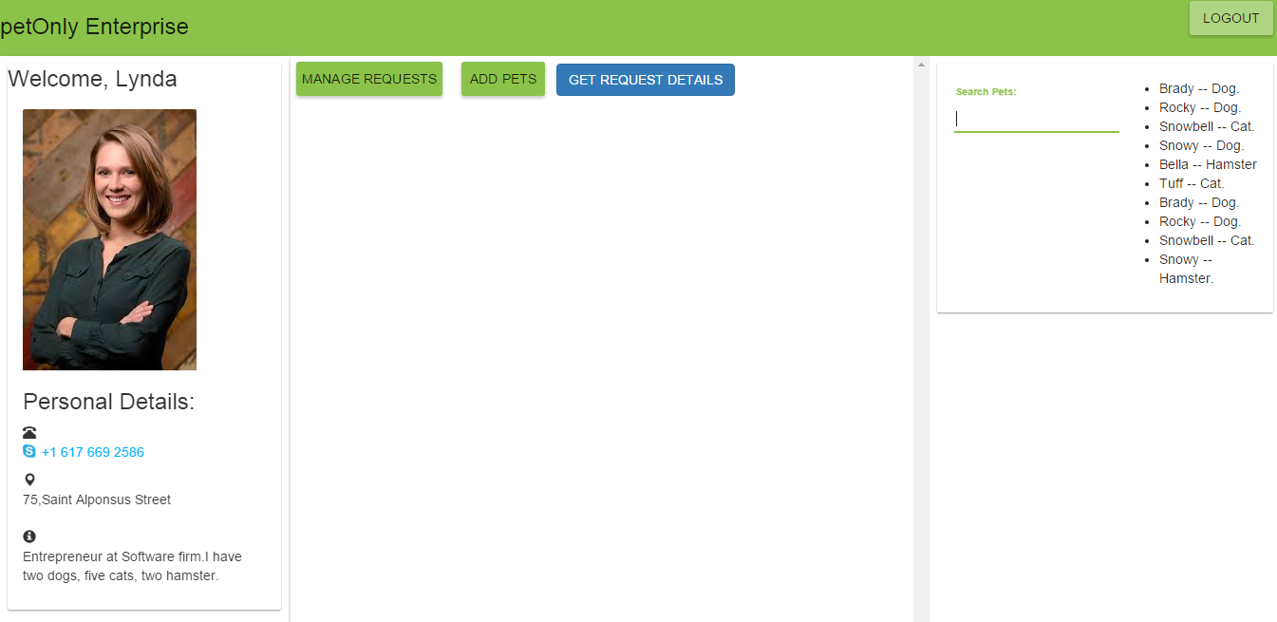

Search feature with filter

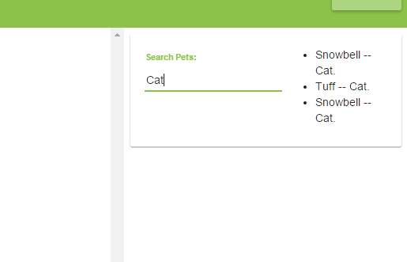

Create Request –with info message.

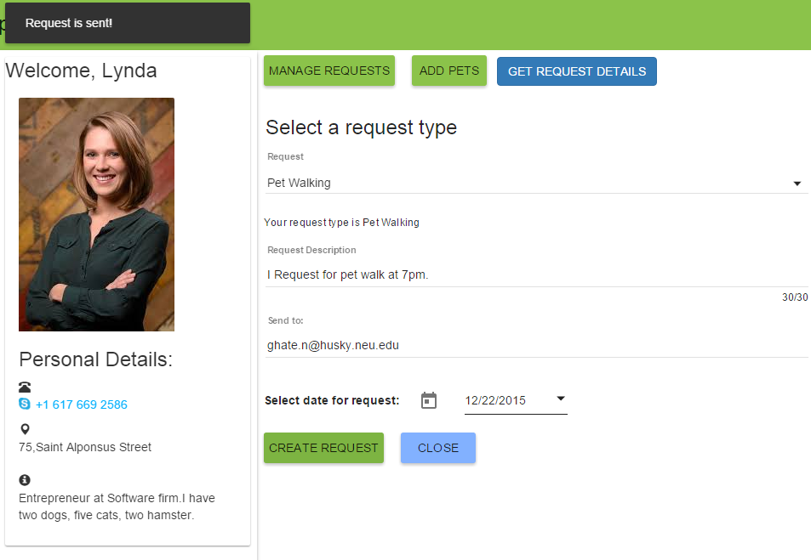

Add Pet

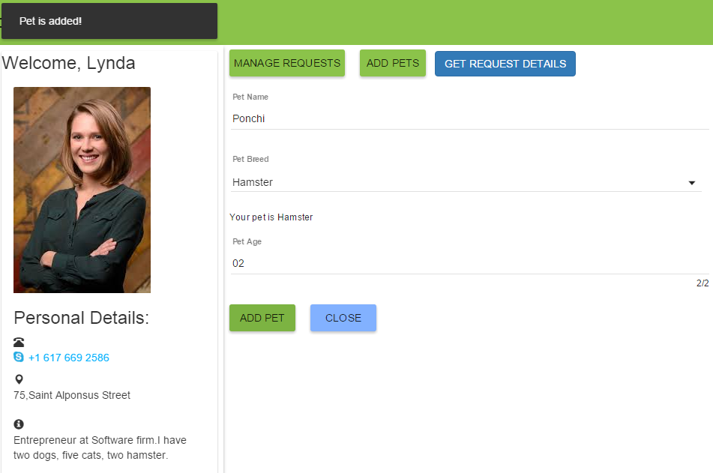

Get Request table by AJAX

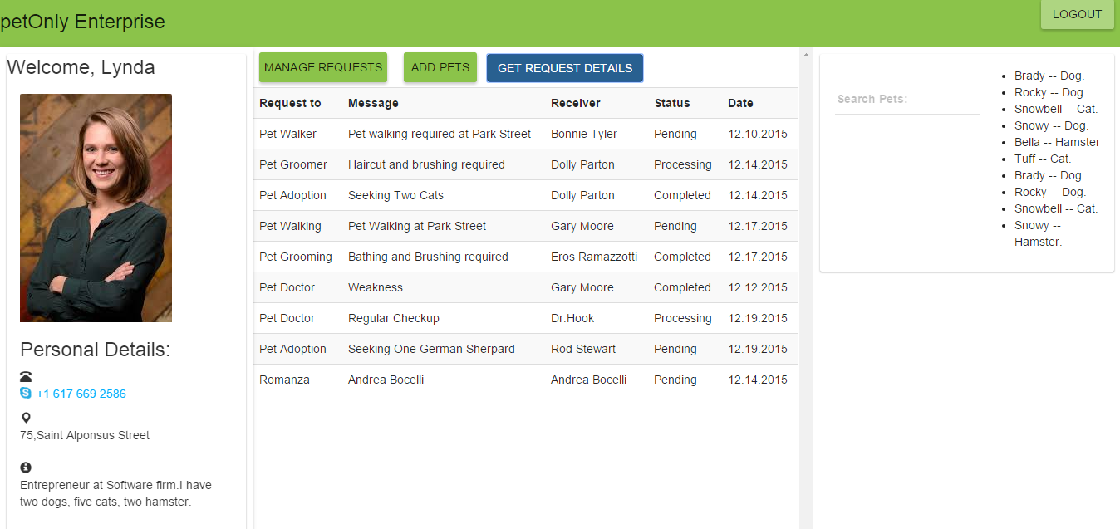

Source codes:

Login.html

<!DOCTYPE html>

<html lang="en" >

<head>

<title>petOnly Enterprise</title>

<meta charset="utf-8">

<meta http-equiv="X-UA-Compatible" content="IE=edge">

<meta name="description" content="">

<meta name="viewport" content="initial-scale=1, maximum-scale=1, user-scalable=no" />

<link rel='stylesheet' href='http://fonts.googleapis.com/css?family=Roboto:400,700'>

<link rel="stylesheet" type="text/css" href="./css/myStyle.css">

<link rel="stylesheet" href="https://cdnjs.cloudflare.com/ajax/libs/angular-material/0.11.4/angular-material.css"/>

<link rel="stylesheet" href="http://maxcdn.bootstrapcdn.com/bootstrap/3.3.5/css/bootstrap.min.css">

<script src="https://ajax.googleapis.com/ajax/libs/jquery/1.11.3/jquery.min.js"></script>

<script src="http://maxcdn.bootstrapcdn.com/bootstrap/3.3.5/js/bootstrap.min.js"></script>

</head>

<!--

✓ Create Angular shell app

✓ Use `bower install angular-material`

✓ Load the CSS (before our app.css),

✓ Load the angular-material.js library and its dependent angular-aria.js and angular-animate.js libraries.

✓ Then set the module dependency on 'ngMaterial'

✓ Use wirefames to determine containers

✓ Configure layouts

✓ Lock open the sideNav, add shadow

✓ Add (hard-coded) HTML content

-> Register Icons

Integrate with App logic

Add Responsiveness

Add Theming

-->

<body layout="column" ng-app="myApp" ng-controller="DemoCtrl as ctrl">

<md-toolbar layout="row">

<h3>petOnly Enterprise</h3>

</md-toolbar>

<md-content >

<div ng-include="template.url"></div>

<!--carousel bootstrap -->

<div>

<carousel interval="myInterval">

<slide ng-repeat="slide in slides" active="slide.active">

<img ng-src="{{slide.image}}">

</slide>

</carousel>

</div>

</md-content>

<div flex layout="row">

<md-sidenav md-is-locked-open="true" class="md-whiteframe-z2">

<div layout="column">

<md-card>

<md-card-title>

<md-card-title-text>

<md-card-title-text>

<span class="md-headline">Login</span>

</md-card-title-text>

<md-card-title-media>

<div class="md-media-lg card-media"></div>

</md-card-title-media>

</md-card-title>

<form ng-submit="login(username, password)">

<md-card-actions layout="column" layout-align="end center">

<md-input-container flex>

<label>Username</label>

<input type="text" ng-model="username" class="ng-pristine ng-valid"/>

</md-input-container>

<md-input-container flex>

<label>Password</label>

<input type="password" ng-model="password" class="ng-pristine ng-valid"/>

</md-input-container>

<br/>

{{loginError}} {{loggedUser}}

<br/><br/>

<md-button class="md-raised md-primary" ng-click="">Login</md-button>

</md-card-actions>

</form>

</md-card>

</div>

</md-sidenav>

<md-content class="md-padding" id="signUP">

<md-card>

<md-card-title>

<md-card-title-text>

<span class="md-headline">SignUp</span>

</md-card-title-text>

<md-card-title-media>

<div class="md-media-lg card-media"></div>

</md-card-title-media>

</md-card-title>

<md-card-actions layout="column" layout-align="end center">

<form ng-submit="$event.preventDefault()" name="searchForm" >

<div flex-gt-sm="80">

<div layout="row" layout-xs="column" layout-sm="column" layout-align="space-between center">

<p>

Please fill out the Sign up form to explore the features of petOnly !

</p>

<md-input-container>

<md-switch ng-model="showHints">Showing {{showHints ? "Hints" : "Errors"}}</md-switch>

</md-input-container>

</div>

</div>

<div layout-gt-sm="row">

<md-input-container class="md-block" flex-gt-sm>

<label>Name</label>

<input md-maxlength="30" required name="name" ng-model="user.name" />

<div class="hint" ng-if="showHints">Tell us what we should call you!</div>

<div ng-messages="searchForm.name.$error" ng-if="!showHints">

<div ng-message="required">Name is required.</div>

<div ng-message="md-maxlength">The name has to be less than 30 characters long.</div>

</div>

</md-input-container>

<div layout-gt-sm="row">

</div>

</div>

<!--sign UP form -->

<md-content layout-padding>

<div layout-gt-sm="row" >

<md-autocomplete flex="" required="" md-input-name="autocompleteField" md-input-minlength="2" md-input-maxlength="18" md-no-cache="ctrl.noCache" md-selected-item="ctrl.selectedItem" md-search-text="ctrl.searchText" md-items="item in ctrl.querySearch(ctrl.searchText)" md-item-text="item.display" md-floating-label="Your state">

<md-item-template>

<span md-highlight-text="ctrl.searchText">{{item.display}}</span>

</md-item-template>

<div ng-messages="searchForm.autocompleteField.$error" ng-if="searchForm.autocompleteField.$touched">

<div ng-message="required">You <b>must</b> have a state.</div>

<div ng-message="minlength">Your entry is not long enough.</div>

<div ng-message="maxlength">Your entry is too long.</div>

</div>

</md-autocomplete>

<div flex="5" hide-xs hide-sm>

<!-- Spacer //-->

</div>

<md-input-container class="md-block" flex-gt-sm>

<label>Social Security Number</label>

<input name="social" ng-model="user.social" ng-pattern="/^[0-9]{3}-[0-9]{2}-[0-9]{4}$/" />

<div class="hint" ng-if="showHints">###-##-####</div>

<div ng-messages="searchForm.social.$error" ng-if="!showHints">

<div ng-message="pattern">###-##-#### - Please enter a valid SSN.</div>

</div>

</md-input-container>

</div>

<div layout-gt-sm="row">

<md-input-container class="md-block" flex-gt-sm>

<label>Email</label>

<input name="email" ng-model="user.email"

required minlength="10" maxlength="100" ng-pattern="/^.+@.+\..+$/" />

<div class="hint" ng-show="showHints">How can we reach you?</div>

<div ng-messages="searchForm.email.$error" ng-hide="showHints">

<div ng-message-exp="['required', 'minlength', 'maxlength', 'pattern']">

Your email must be between 10 and 100 characters long and look like an e-mail address.

</div>

</div>

</md-input-container>

<div flex="5" hide-xs hide-sm>

<!-- Spacer //-->

</div>

<md-input-container class="md-block" flex-gt-sm>

<label>Phone Number</label>

<input name="phone" ng-model="user.phone" ng-pattern="/^([0-9]{3}) [0-9]{3}-[0-9]{4}$/" />

<div class="hint" ng-show="showHints">(###) ###-####</div>

<div ng-messages="searchForm.phone.$error" ng-hide="showHints">

<div ng-message="pattern">(###) ###-#### - Please enter a valid phone number.</div>

</div>

</md-input-container>

<style>

/*

* The Material demos system does not currently allow targeting the body element, so this

* must go here in the HTML.

*/

body[dir=rtl] .hint {

right: 2px;

left: auto;

}

</style>

</div>

<md-button class="md-raised md-primary">Sign up</md-button>

</form>

</md-content>

</form>

</md-card-actions>

</md-card>

</md-content>

</div>

<!-- Angular Material requires Angular.js Libraries -->

<script src="https://ajax.googleapis.com/ajax/libs/angularjs/1.5.0-rc.0/angular.min.js"></script>

<script src="https://cdnjs.cloudflare.com/ajax/libs/angular-material/0.11.4/angular-material.js"></script>

<script src="https://cdnjs.cloudflare.com/ajax/libs/angular.js/1.5.0-rc.0/angular-animate.js"></script>

<script src="https://cdnjs.cloudflare.com/ajax/libs/angular.js/1.5.0-rc.0/angular-aria.js"></script>

<script src="http://ajax.googleapis.com/ajax/libs/angularjs/1.4.8/angular-messages.min.js"></script>

<script src="https://ajax.googleapis.com/ajax/libs/angularjs/1.4.8/angular-route.min.js"></script>

<!-- Angular Material Library -->

<script src="https://cdnjs.cloudflare.com/ajax/libs/angular.js/1.5.0-rc.0/angular-animate.min.js"></script>

<script type="text/javascript" src="//cdnjs.cloudflare.com/ajax/libs/angular-ui-bootstrap/0.10.0/ui-bootstrap-tpls.min.js"></script>

<script src="./users/DemoController.js"></script>

</body>

</html>

Admin.html

<!DOCTYPE html>

<html lang="en" >

<head>

<title>petOnly Enterprise</title>

<meta charset="utf-8">

<meta http-equiv="X-UA-Compatible" content="IE=edge">

<meta name="description" content="">

<meta name="viewport" content="initial-scale=1, maximum-scale=1, user-scalable=no" />

<link rel='stylesheet' href='http://fonts.googleapis.com/css?family=Roboto:400,700'>

<link rel="stylesheet" type="text/css" href="./css/myang6Style.css">

<link rel="stylesheet" href="https://cdnjs.cloudflare.com/ajax/libs/angular-material/0.11.4/angular-material.css"/>

<script src="https://cdnjs.cloudflare.com/ajax/libs/angular.js/1.5.0-rc.0/angular.js"></script>

<link rel="stylesheet" href="http://maxcdn.bootstrapcdn.com/bootstrap/3.3.5/css/bootstrap.min.css">

<script src="https://ajax.googleapis.com/ajax/libs/jquery/1.11.3/jquery.min.js"></script>

<script src="http://maxcdn.bootstrapcdn.com/bootstrap/3.3.5/js/bootstrap.min.js"></script>

</head>

<!--

✓ Create Angular shell app

✓ Use `bower install angular-material`

✓ Load the CSS (before our app.css),

✓ Load the angular-material.js library and its dependent angular-aria.js and angular-animate.js libraries.

✓ Then set the module dependency on 'ngMaterial'

✓ Use wirefames to determine containers

✓ Configure layouts

✓ Lock open the sideNav, add shadow

✓ Add (hard-coded) HTML content

-> Register Icons

Integrate with App logic

Add Responsiveness

Add Theming

-->

<body layout="column" ng-app="myApp" ng-controller="AppCtrl">

<md-toolbar layout="row">

<h2>petOnly Enterprise</h2>

<span flex></span>

<form ng-submit="logout()">

<md-button class="md-raised md-primary md-hue-1" ng-click="logout()">Logout</md-button>

</form>

</md-toolbar>

<div flex layout="row">

<md-sidenav md-is-locked-open="true" class="md-whiteframe-z2" style="height: 800px;">

<div layout="column">

<md-card >

<md-card-title>

<md-card-title-text>

<span class="md-headline">Welcome, Samantha</span>

</md-card-title-text>

</md-card-title>

<md-card-content layout="column" layout-align="space-between">

<div class="md-media-md card-media">

<img ng-src="{{imagePath}}" class="md-card-image" alt="Washed Out">

</div>

<div>

<h3>Personal Details:</h3>

<span class="glyphicon glyphicon-phone-alt" aria-hidden="true"></span>

<p>+1 617 669 2586</p>

<span class="glyphicon glyphicon-map-marker" aria-hidden="true"></span>

<address>75,Saint Alponsus Street</address>

<span class="glyphicon glyphicon-info-sign" aria-hidden="true"></span>

<p>Working as manager in petOnly enterpise. Previous experience at pet adoption center for five years.</p>

</div>

<md-card-actions layout="row" >

<md-button class="md-icon-button" data-toggle="modal" data-target="#myModal" aria-label="Edit">

<md-tooltip md-direction="bottom" >Edit Profile</md-tooltip>

<span class="glyphicon glyphicon-pencil" aria-hidden="true"></span>

</md-button>

<!-- Button trigger modal -->

<md-button class="md-icon-button" aria-label="Messages" ng-click="toggleCustom()" >

<md-tooltip md-direction="bottom">Messages</md-tooltip>

<span class="glyphicon glyphicon-envelope" aria-hidden="true"></span>

<span class="badge">12</span>

</md-button>

<md-button class="md-icon-button" data-toggle="modal" data-target="#myModalEmail" aria-label="Share">

<md-tooltip md-direction="bottom">Email</md-tooltip>

<span class="glyphicon glyphicon-send" aria-hidden="true"></span>

</md-button>

</md-card-actions>

</md-card-content>

</md-card>

</div>

<!--div for messages -->

<div id="messages">

<md-list ng-hide="custom">

<md-subheader class="md-no-sticky">Messages for you</md-subheader>

<md-list-item class="md-3-line" ng-repeat="item in todos">

<img ng-src="{{item.face}}?{{$index}}" class="md-avatar" alt="{{item.who}}" />

<div class="md-list-item-text" layout="column">

<h3>{{ item.who }}</h3>

<h4>{{ item.what }}</h4>

<p>{{ item.notes }}</p>

</div>

</md-list-item>

</md-list>

</div>

</md-sidenav>

<!-- Modal for edit -->

<div class="modal fade" id="myModal" tabindex="-1" role="dialog" aria-labelledby="myModalLabel">

<div class="modal-dialog" role="document">

<div class="modal-content">

<div class="modal-header">

<button type="button" class="close" data-dismiss="modal" aria-label="Close"><span aria-hidden="true">&times;

</span></button>

<h4 class="modal-title" id="myModalLabel">Edit Profile</h4>

</div>

<div class="modal-body">

<form role="form">

<div class="form-group">

<label for="addr">Address:</label>

<input type="text" class="form-control" id="addr">

</div>

<div class="form-group">

<label for="phn">Phone Number:</label>

<input type="text" class="form-control" id="phn">

</div>

<div class="form-group">

<label for="profileInfo">Profile Info:</label>

<textarea class="form-control" rows="5" id="profileInfo"></textarea>

</div>

</form>

</div>

<div class="modal-footer">

<button type="button" class="btn btn-default" data-dismiss="modal">Close</button>

<button type="button" class="btn btn-primary">Save changes</button>

</div>

</div>

</div>

</div>

<!-- Modal for email -->

<div class="modal fade" id="myModalEmail" tabindex="-1" role="dialog" aria-labelledby="myModalLabel">

<div class="modal-dialog" role="document">

<div class="modal-content">

<div class="modal-header">

<button type="button" class="close" data-dismiss="modal" aria-label="Close"><span aria-hidden="true">&times;

</span></button>

<h4 class="modal-title" id="myModalLabel">Edit Profile</h4>

</div>

<div class="modal-body">

<form role="form">

<div class="form-group">

<label for="emailaddr">Email Address:</label>

<input type="text" class="form-control" id="emailaddr">

</div>

<div class="form-group">

<label for="emailBody">Email Body:</label>

<textarea class="form-control" rows="5" id="emailBody"></textarea>

</div>

</form>

</div>

<div class="modal-footer">

<button type="button" class="btn btn-default" data-dismiss="modal">Close</button>

<button type="button" class="btn btn-primary">Send Email</button>

</div>

</div>

</div>

</div>

<md-content>

<md-tabs md-dynamic-height md-border-bottom>

<md-tab label="Users">

<md-content class="md-padding signUP">

<h4 class="md-display-1">Users in the Enterprise</h4>

<p>The List of Pet owners and their details.</p>

<div class="row">

<table id="demo1" class="table table-striped" ng-controller="AppCtrl1">

<tr>

<th>Sr. No.</td>

<th>Owner Name</th>

<th>Location </th>

<th>Number of Pets Owned</th>

<th>Number of Requests</th>

</tr>

<tr ng-repeat="x in names">

<td>{{ $index + 1 }}</td>

<td>{{ x.Name }}</td>

<td>{{ x.City | uppercase}}</td>

<td>{{ x.Pets }}</td>

<td>{{ x.Requests }}</td>

</tr>

</table>

</div>

</md-content>

</md-tab>

<md-tab label="Pets and Requests">

<md-content class="md-padding signUP">

<h1 class="md-display-1">Pets in the Enterprise</h1>

<button type="button" onclick="loadDoc()" class="btn btn-primary">See Requests</button>

<div>

<table id="demo" class="table table-striped"></table>

</div>

</md-content>

</md-tab>

<md-tab label="Statistics">

<md-content class="md-padding signUP">

<h1 class="md-display-2">Statistics</h1>

<p>Number of requests per pet owner.</p>

<div class="chart"></div>

</md-content>

</md-tab>

</md-tabs>

</md-content>

</div>

<footer>

<div layout="row" layout-align="center center">

<p>Copyrights: petOnly Enterprise</p>

</div>

</footer>

<!--footer <footer class="footer">

<div class="container">

<p class="text-muted">Place sticky footer content here.</p>

</div>

</footer> -->

<!-- Angular Material requires Angular.js Libraries -->

<script src="https://cdnjs.cloudflare.com/ajax/libs/angular.js/1.5.0-rc.0/angular-animate.js"></script>

<script src="https://cdnjs.cloudflare.com/ajax/libs/angular.js/1.5.0-rc.0/angular-aria.js"></script>

<script src="http://ajax.googleapis.com/ajax/libs/angularjs/1.4.8/angular-messages.min.js"></script>

<script src="https://ajax.googleapis.com/ajax/libs/angularjs/1.4.8/angular-route.min.js"></script>

<!-- Angular Material Library -->

<script src="https://cdnjs.cloudflare.com/ajax/libs/angular.js/1.5.0-rc.0/angular-animate.min.js"></script>

<script src="https://cdnjs.cloudflare.com/ajax/libs/angular-material/0.11.4/angular-material.js"></script>

<script src="http://d3js.org/d3.v3.min.js" charset="utf-8"></script>

<!-- <script src="C:/My Work/WebDesign/Project/users/DemoController.js"></script>-->

<script type="text/javascript" src="./users/d3graph.js" ></script>

<script type="text/javascript">

var app = angular.module('myApp', ['ngMaterial']);

app.controller('AppCtrl', function($scope, $http) {

$scope.imagePath = './images/img2.jpe';

$http.get("https://api.myjson.com/bins/1y915")

.then(function (response) {$scope.names = response.data.records;});

$scope.custom = true;

$scope.toggleCustom = function() {

$scope.custom = $scope.custom === false ? true: false;

};

var imagePath = './images/jsmith.jpg';

$scope.phones = [

{ type: 'Home', number: '(555) 251-1234' },

{ type: 'Cell', number: '(555) 786-9841' },

{ type: 'Office', number: '(555) 314-1592' }

];

$scope.todos = [

{

face : imagePath,

what: 'Brunch this weekend?',

who: 'Min Li Chan',

when: '3:08PM',

notes: " I'll be in your neighborhood doing errands"

},

{

face : imagePath,

what: 'Brunch this weekend?',

who: 'Min Li Chan',

when: '3:08PM',

notes: " I'll be in your neighborhood doing errands"

},

{

face : imagePath,

what: 'Brunch this weekend?',

who: 'Min Li Chan',

when: '3:08PM',

notes: " I'll be in your neighborhood doing errands"

},

{

face : imagePath,

what: 'Brunch this weekend?',

who: 'Min Li Chan',

when: '3:08PM',

notes: " I'll be in your neighborhood doing errands"

},

{

face : imagePath,

what: 'Brunch this weekend?',

who: 'Min Li Chan',

when: '3:08PM',

notes: " I'll be in your neighborhood doing errands"

},

{

face : imagePath,

what: 'Brunch this weekend?',

who: 'Min Li Chan',

when: '3:08PM',

notes: " I'll be in your neighborhood doing errands"

},

{

face : imagePath,

what: 'Brunch this weekend?',

who: 'Min Li Chan',

when: '3:08PM',

notes: " I'll be in your neighborhood doing errands"

},

];

$scope.logout = function() {

window.location = "login.html";

};

});

app.controller('AppCtrl1', function($scope, $http) {

$http.get("./users/users1.php")

.then(function (response) {$scope.names = response.data.records;});

});

app.config(function( $mdThemingProvider){

$mdThemingProvider.theme('default')

.primaryPalette('light-green')

.accentPalette('deep-purple');

})

</script>

<script>

function loadDoc() {

var xhttp = new XMLHttpRequest();

xhttp.onreadystatechange = function() {

if (xhttp.readyState == 4 && xhttp.status == 200) {

myFunction(xhttp);

}

};

xhttp.open("GET", "requestscatalog.xml", true);

xhttp.send();

}

function myFunction(xml) {

var i;

var xmlDoc = xml.responseXML;

var table="<tr><th>Request to</th><th>Message</th><th>Sender</th><th>Status</th><th>Date</th></tr>";

var x = xmlDoc.getElementsByTagName("Request");

for (i = 0; i <x.length; i++) {

table += "<tr><td>" +

x[i].getElementsByTagName("TITLE")[0].childNodes[0].nodeValue +

"</td><td>" +

x[i].getElementsByTagName("MESSAGE")[0].childNodes[0].nodeValue +

"</td><td>"+

x[i].getElementsByTagName("RECEIVER")[0].childNodes[0].nodeValue +

"</td><td>" +

x[i].getElementsByTagName("STATUS")[0].childNodes[0].nodeValue +

"</td><td>"+

x[i].getElementsByTagName("DATE")[0].childNodes[0].nodeValue +

"</td></tr>";

}

document.getElementById("demo").innerHTML = table;

}

</script>

</body>

</html>

User.html

<!DOCTYPE html>

<html lang="en" >

<head>

<title>petOnly Enterprise</title>

<meta charset="utf-8">

<meta http-equiv="X-UA-Compatible" content="IE=edge">

<meta name="description" content="">

<meta name="viewport" content="initial-scale=1, maximum-scale=1, user-scalable=no" />

<link rel='stylesheet' href='http://fonts.googleapis.com/css?family=Roboto:400,700'>

<link rel="stylesheet" type="text/css" href="./css/myang4Style.css">

<link rel="stylesheet" href="https://cdnjs.cloudflare.com/ajax/libs/angular-material/0.11.4/angular-material.css"/>

<script src="https://ajax.googleapis.com/ajax/libs/angularjs/1.5.0-rc.0/angular.min.js"></script>

<link rel="stylesheet" href="http://maxcdn.bootstrapcdn.com/bootstrap/3.3.5/css/bootstrap.min.css">

<script src="https://ajax.googleapis.com/ajax/libs/jquery/1.11.3/jquery.min.js"></script>

<script src="http://maxcdn.bootstrapcdn.com/bootstrap/3.3.5/js/bootstrap.min.js"></script>

</head>

<!--

✓ Create Angular shell app

✓ Use `bower install angular-material`

✓ Load the CSS (before our app.css),

✓ Load the angular-material.js library and its dependent angular-aria.js and angular-animate.js libraries.

✓ Then set the module dependency on 'ngMaterial'

✓ Use wirefames to determine containers

✓ Configure layouts

✓ Lock open the sideNav, add shadow

✓ Add (hard-coded) HTML content

-> Register Icons

Integrate with App logic

Add Responsiveness

Add Theming

-->

<body layout="column" ng-app="myApp" ng-controller="formCtrl" >

<md-toolbar layout="row">

<h3>petOnly Enterprise</h3>

<span flex></span>

<form ng-submit="logout()">

<md-button class="md-raised md-primary md-hue-1" ng-click="logout()">Logout</md-button>

</form>

</md-toolbar>

<div flex layout="row" >

<md-sidenav md-is-locked-open="true" class="md-whiteframe-z2" style="height: 800px;">

<div layout="column">

<md-card >

<md-card-title>

<md-card-title-text>

<span class="md-headline">Welcome, Lynda</span>

</md-card-title-text>

</md-card-title>

<md-card-content layout="column" layout-align="space-between">

<div class="md-media-md card-media">

<img ng-src="{{imagePath}}" class="md-card-image" alt="Washed Out">

</div>

<div>

<h3>Personal Details:</h3>

<span class="glyphicon glyphicon-phone-alt" aria-hidden="true"></span>

<p>+1 617 669 2586</p>

<span class="glyphicon glyphicon-map-marker" aria-hidden="true"></span>

<address>75,Saint Alponsus Street</address>

<span class="glyphicon glyphicon-info-sign" aria-hidden="true"></span>

<p>Entrepreneur at Software firm.I have two dogs, five cats, two hamster.</p>

</div>

</md-card-content>

</md-card>

</div>

</md-sidenav>

<md-content class="signUP">

<md-button ng-click="showme=true" class="md-raised md-primary">Manage Requests</md-button>

<md-button ng-click="showme1=true" class="md-raised md-primary">Add Pets</md-button>

<button type="button" onclick="loadDoc()" class="btn btn-primary">GET REQUEST DETAILS</button>

<div class="wrapper" ng-show="showme">

<div layout="column" ng-cloak>

<md-content layout-padding>

<form name="projectForm">

<md-input-container class="md-block">

<h3>Select a request type</h3>

<label>Request</label>

<md-select ng-model="ownerRequest" >

<md-option ng-repeat="ownerRequest in ownerRequests" value="{{ownerRequest}}">{{ownerRequest}}</md-option>

</md-select>

</md-input-container>

<p class="md-caption">Your request type is {{ ownerRequest ? ownerRequest : 'No one yet' }}</p>

<md-input-container class="md-block">

<label>Request Description</label>

<input md-maxlength="30" required name="description" ng-model="project.description">

<div ng-messages="projectForm.description.$error">

<div ng-message="required">This is required.</div>

<div ng-message="md-maxlength">The name has to be less than 30 characters long.</div>

</div>

</md-input-container>

<md-input-container class="md-block">

<label>Send to: </label>

<input required type="email" name="clientEmail" ng-model="project.clientEmail"

minlength="10" maxlength="100" ng-pattern="/^.+@.+\..+$/" />

<div ng-messages="projectForm.clientEmail.$error" role="alert">

<div ng-message-exp="['required', 'minlength', 'maxlength', 'pattern']">

Your email must be between 10 and 100 characters long and look like an e-mail address.

</div>

</div>

</md-input-container>

<label>Select date for request: </label>

<md-datepicker ng-model="myDate" md-placeholder="Enter date"></md-datepicker>

</form>

</md-content>

</div>

<md-button class="md-raised md-primary" ng-click="showSimpleToast()">Create Request</md-button>

<md-button class="md-accent md-raised md-hue-1" ng-click="showme=false">Close</md-button>

</div>

<!-- for add pets -->

<div class="wrapper" ng-show="showme1">

<div layout="column" ng-cloak>

<md-content layout-padding>

<form name="projectForm">

<md-input-container class="md-block">

<label>Pet Name</label>

<input required name="clientName" ng-model="project.clientName">

<div ng-messages="projectForm.clientName.$error">

<div ng-message="required">This is required.</div>

</div>

</md-input-container>

<md-input-container style="margin-right: 10px;">

<label>Pet Breed</label>

<md-select ng-model="size" >

<md-option ng-repeat="size in sizes" value="{{size}}">{{size}}</md-option>

</md-select>

</md-input-container>

<p class="md-caption">Your pet is {{ size ? size : 'No one yet' }}</p>

<md-input-container class="md-block">

<label>Pet Age</label>

<input name="postalCode" ng-model="user.postalCode" placeholder="02 Years"

required ng-pattern="/^[0-9]{2}$/" md-maxlength="2">

<div ng-messages="projectForm.postalCode.$error" role="alert" multiple>

<div ng-message="required" class="my-message">You must supply your Pet age.</div>

<div ng-message="pattern" class="my-message">That doesn't look like a valid age.

</div>

<div ng-message="md-maxlength" class="my-message">

Too long...Am sure your pet isnt that old !!

</div>

</div>

</md-input-container>

</form>

</md-content>

</div>

<md-button class="md-raised md-primary" ng-click="showSimpleToast1()">Add Pet</md-button>

<md-button class="md-accent md-raised md-hue-1" ng-click="showme1=false">Close</md-button>

</div>

<div>

<table id="demo" class="table table-striped"></table>

</div>

</md-content>

<md-content>

<md-card>

<md-card-content>

<!--Sidebar content-->

<div layout="row">

<md-input-container class="md-block">

<label>Search Pets: </label>

<input ng-model="query">

</md-input-container>

<!--Body content-->

<ul class="phones">

<li ng-repeat="phone in phones | filter:query">

<span>{{phone.name}} -- {{phone.snippet}}</span>

</li>

</ul>

</div>

</md-card-content>

</md-card>

</md-content>

</div>

<!-- Angular Material requires Angular.js Libraries -->

<script src="https://cdnjs.cloudflare.com/ajax/libs/angular.js/1.5.0-rc.0/angular-animate.js"></script>

<script src="https://cdnjs.cloudflare.com/ajax/libs/angular.js/1.5.0-rc.0/angular-aria.js"></script>

<script src="http://ajax.googleapis.com/ajax/libs/angularjs/1.4.8/angular-messages.min.js"></script>

<script src="https://ajax.googleapis.com/ajax/libs/angularjs/1.4.8/angular-route.min.js"></script>

<!-- Angular Material Library -->

<script src="https://cdnjs.cloudflare.com/ajax/libs/angular.js/1.5.0-rc.0/angular-animate.min.js"></script>

<script src="https://cdnjs.cloudflare.com/ajax/libs/angular.js/1.5.0-rc.0/angular-sanitize.min.js"></script>

<script src="https://cdnjs.cloudflare.com/ajax/libs/angular-material/0.11.4/angular-material.js"></script>

<!-- <script src="C:/My Work/WebDesign/Project/users/DemoController.js"></script>-->

<script type="text/javascript">

var app = angular.module('myApp', ['ngMaterial','ngMessages','ngAnimate']);

app.controller('formCtrl', function($scope,$mdToast, $document) {

//$scope.clicked =

// function(){

//window.location = "ang1.html";

// }

$scope.project = {

description: 'I Request - ',

clientEmail : 'youremailAddress@example.com'

};

$scope.imagePath = './images/img1.jpe';

$scope.sizes = [

"Dog",

"Cat",

"Hamster",

"Rabbit",

"Parrot"

];

$scope.ownerRequests = [

"Pet Walking",

"Pet Grooming",

"Pet Adoption",

"Pet Give away",

"Pet Doctor"

];

$scope.phones = [

{'name': 'Brady',

'snippet': 'Dog.'},

{'name': 'Rocky',

'snippet': 'Dog.'},

{'name': 'Snowbell',

'snippet': 'Cat.'},

{'name': 'Snowy',

'snippet': 'Dog.'},

{'name': 'Bella',

'snippet': 'Hamster'},

{'name': 'Tuff',

'snippet': 'Cat.'},

{'name': 'Brady',

'snippet': 'Dog.'},

{'name': 'Rocky',

'snippet': 'Dog.'},

{'name': 'Snowbell',

'snippet': 'Cat.'},

{'name': 'Snowy',

'snippet': 'Hamster.'}

];

$scope.showSimpleToast = function() {

// $mdToast.show($mdToast.simple().content('Hello!'));

$mdToast.show(

$mdToast.simple()

.content('Request is sent!')

.position( "top left")

.hideDelay(3000)

);

};

$scope.showSimpleToast1 = function() {

// $mdToast.show($mdToast.simple().content('Hello!'));

$mdToast.show(

$mdToast.simple()

.content('Pet is added!')

.position( "top left")

.hideDelay(3000)

);

};

$scope.logout = function() {

window.location = "login.html";

};

});

app.config(function( $mdThemingProvider){

$mdThemingProvider.theme('default')

.primaryPalette('light-green')

.accentPalette('blue');

})

</script>

<script>

function loadDoc() {

var xhttp = new XMLHttpRequest();

xhttp.onreadystatechange = function() {

if (xhttp.readyState == 4 && xhttp.status == 200) {

myFunction(xhttp);

}

};

xhttp.open("GET", "requestscatalog.xml", true);

xhttp.send();

}

function myFunction(xml) {

var i;

var xmlDoc = xml.responseXML;

var table="<tr><th>Request to</th><th>Message</th><th>Receiver</th><th>Status</th><th>Date</th></tr>";

var x = xmlDoc.getElementsByTagName("Request");

for (i = 0; i <x.length; i++) {

table += "<tr><td>" +

x[i].getElementsByTagName("TITLE")[0].childNodes[0].nodeValue +

"</td><td>" +

x[i].getElementsByTagName("MESSAGE")[0].childNodes[0].nodeValue +

"</td><td>"+

x[i].getElementsByTagName("RECEIVER")[0].childNodes[0].nodeValue +

"</td><td>" +

x[i].getElementsByTagName("STATUS")[0].childNodes[0].nodeValue +

"</td><td>"+

x[i].getElementsByTagName("DATE")[0].childNodes[0].nodeValue +

"</td></tr>";

}

document.getElementById("demo").innerHTML = table;

}

</script>

</body>

</html>

DemoController.js

(function () {

'use strict';

var app =angular

.module('myApp',['ngMaterial', 'ngMessages','ui.bootstrap']);

app.controller('DemoCtrl', DemoCtrl);

function DemoCtrl ($timeout, $q, $scope) {

var self = this;

$scope.showHints = true;

$scope.user = {

name: "",

email: "",

social: "123456789",

phone: ""

};

$scope.login = function (username, password) {

if ( username === 'admin' && password === 'admin') {

//authentication.isAuthenticated = true;

$scope.user = username;

window.location = "admin.html";

}else

if( username === 'neha' && password === 'neha') {

//authentication.isAuthenticated = true;

$scope.user = username;

window.location = "user.html";

} else {

$scope.loginError = "Invalid username/password combination";

};

};

app.factory('Auth', function(){

var user;

return{

setUser : function(aUser){

user = aUser;

},

isLoggedIn : function(){

return(user)? user : false;

}

}

})

app.run(['$rootScope', '$location', 'Auth', function ($rootScope, $location, Auth) {

$rootScope.$on('$routeChangeStart', function (event) {

if (!Auth.isLoggedIn()) {

console.log('DENY');

event.preventDefault();

$location.path('/login');

}

else {

console.log('ALLOW');

$location.path('/home');

}

});

}]);

$scope.myInterval = 3000;

$scope.slides = [

{

image: './images/carousel1.jpe'

},

{

image: './images/carousel2.jpe'

},

{

image: './images/carousel3.jpe'

},

{

image: './images/carousel4.jpe'

}

];

// list of `state` value/display objects

self.states = loadAll();

self.selectedItem = null;

self.searchText = null;

self.querySearch = querySearch;

// ******************************

// Internal methods

// ******************************

/**

* Search for states... use $timeout to simulate

* remote dataservice call.

*/

function querySearch (query) {

var results = query ? self.states.filter( createFilterFor(query) ) : [];

return results;

}

/**

* Build `states` list of key/value pairs

*/

function loadAll() {

var allStates = 'Alabama, Alaska, Arizona, Arkansas, California, Colorado, Connecticut, Delaware,\

Florida, Georgia, Hawaii, Idaho, Illinois, Indiana, Iowa, Kansas, Kentucky, Louisiana,\

Maine, Maryland, Massachusetts, Michigan, Minnesota, Mississippi, Missouri, Montana,\

Nebraska, Nevada, New Hampshire, New Jersey, New Mexico, New York, North Carolina,\

North Dakota, Ohio, Oklahoma, Oregon, Pennsylvania, Rhode Island, South Carolina,\

South Dakota, Tennessee, Texas, Utah, Vermont, Virginia, Washington, West Virginia,\

Wisconsin, Wyoming';

return allStates.split(/, +/g).map( function (state) {

return {

value: state.toLowerCase(),

display: state

};

});

}

/**

* Create filter function for a query string

*/

function createFilterFor(query) {

var lowercaseQuery = angular.lowercase(query);

return function filterFn(state) {

return (state.value.indexOf(lowercaseQuery) === 0);

};

}

app

.config(function( $mdThemingProvider){

$mdThemingProvider.theme('default')

.primaryPalette('green')

.accentPalette('red');

})

}

})();

D3graph.js

var data = [4, 8, 15, 16, 22, 12,5, 11, 13, 2, 10];

var x = d3.scale.linear()

.domain([0, d3.max(data)])

.range([0, 420]);

d3.select(".chart")

.selectAll("div")

.data(data)

.enter().append("div")

.style("width", function(d) { return x(d) + "px"; })

.text(function(d) { return d; });

Users.php

{

"records": [

{

"Name" : "Alfreds Futterkiste",

"City" : "Berlin",

"Pets" : "1",

"Requests" : "4"

},

{

"Name" : "Berglunds snabbköp",

"City" : "Luleå",

"Pets" : "5",

"Requests" : "8"

},

{

"Name" : "Centro comercial Moctezuma",

"City" : "México D.F.",

"Pets" : "2",

"Requests" : "4"

},

{

"Name" : "Ernst Handel",

"City" : "Graz",

"Pets" : "1",

"Requests" : "6"

},

{

"Name" : "FISSA Fabrica Inter. Salchichas S.A.",

"City" : "Madrid",

"Pets" : "1",

"Requests" : "4"

},

{

"Name" : "Galería del gastrónomo",

"City" : "Barcelona",

"Pets" : "1",

"Requests" : "7"

},

{

"Name" : "Island Trading",

"City" : "Cowes",

"Pets" : "1",

"Requests" : "4"

},

{

"Name" : "Königlich Essen",

"City" : "Brandenburg",

"Pets" : "5",

"Requests" : "4"

},

{

"Name" : "Laughing Bacchus Wine Cellars",

"City" : "Vancouver",

"Pets" : "3",

"Requests" : "4"

},

{

"Name" : "Magazzini Alimentari Riuniti",

"City" : "Bergamo",

"Pets" : "9",

"Requests" : "6"

},

{

"Name" : "North/South",

"City" : "London",

"Pets" : "5",

"Requests" : "4"

},

{

"Name" : "Paris spécialités",

"City" : "Paris",

"Pets" : "3",

"Requests" : "8"

},

{

"Name" : "Rattlesnake Canyon Grocery",

"City" : "Albuquerque",

"Pets" : "1",

"Requests" : "4"

},

{

"Name" : "Simons bistro",

"City" : "København",

"Pets" : "3",

"Requests" : "4"

},

{

"Name" : "The Big Cheese",

"City" : "Portland",

"Pets" : "3",

"Requests" : "14"

},

{

"Name" : "Vaffeljernet",

"City" : "Århus",

"Pets" : "4",

"Requests" : "7"

},

{

"Name" : "Wolski Zajazd",

"City" : "Warszawa",

"Pets" : "2",

"Requests" : "6"

}

]

}

Myang6style.css

/* for ang6 mdcontent*/

.signUP{

width: 800px;

height: 500px;

overflow-y: scroll;

}

.tabsdemoDynamicHeight md-content {

background-color: transparent !important; }

.tabsdemoDynamicHeight md-content md-tabs {

background: #f6f6f6;

border: 1px solid #e1e1e1; }

.tabsdemoDynamicHeight md-content md-tabs md-tabs-wrapper {

background: white; }

.tabsdemoDynamicHeight md-content h1:first-child {

margin-top: 0; }

.chart div {

font: 10px sans-serif;

background-color: steelblue;

text-align: right;

padding: 3px;

margin: 1px;

color: white;

}

.bar {

fill: steelblue;

}

.axis text {

font: 10px sans-serif;

}

.axis path,

.axis line {

fill: none;

stroke: #000;

shape-rendering: crispEdges;

}

.x.axis path {

display: none;

}

Myang4style.css

/* for ang 4*/

.signUP{

width: 700px;

height: 732px;

overflow-y: scroll;

}

myStyle.css

/* myStyle for ang 3*/

#slides_control > div{

height: 200px;

}

img{

margin:auto;

width: 400px;

}

#slides_control {

position:absolute;

width: 400px;

left:50%;

top:20px;

margin-left:-200px;

}

#signUP{

width: 700px;

height: 732px;

}

Request catalog.xml

<CATALOG>

<Request>

<TITLE>Pet Walker</TITLE>

<MESSAGE>Pet walking required at Park Street</MESSAGE>

<RECEIVER>Bonnie Tyler</RECEIVER>

<STATUS>Pending</STATUS>

<DATE>12.10.2015</DATE>

</Request>

<Request>

<TITLE>Pet Groomer</TITLE>

<MESSAGE>Haircut and brushing required</MESSAGE>

<RECEIVER>Dolly Parton</RECEIVER>

<STATUS>Processing</STATUS>

<DATE>12.14.2015</DATE>

</Request>

<Request>

<TITLE>Pet Adoption</TITLE>

<MESSAGE>Seeking Two Cats</MESSAGE>

<RECEIVER>Dolly Parton</RECEIVER>

<STATUS>Completed</STATUS>

<DATE>12.14.2015</DATE>

</Request>

<Request>

<TITLE>Pet Walking</TITLE>

<MESSAGE>Pet Walking at Park Street</MESSAGE>

<RECEIVER>Gary Moore</RECEIVER>

<STATUS>Pending</STATUS>

<DATE>12.17.2015</DATE>

</Request>

<Request>

<TITLE>Pet Grooming</TITLE>

<MESSAGE>Bathing and Brushing required</MESSAGE>

<RECEIVER>Eros Ramazzotti</RECEIVER>

<STATUS>Completed</STATUS>

<DATE>12.17.2015</DATE>

</Request>

<Request>

<TITLE>Pet Doctor</TITLE>

<MESSAGE>Weakness</MESSAGE>

<RECEIVER>Gary Moore</RECEIVER>

<STATUS>Completed</STATUS>

<DATE>12.12.2015</DATE>

</Request>

<Request>

<TITLE>Pet Doctor</TITLE>

<MESSAGE>Regular Checkup</MESSAGE>

<RECEIVER>Dr.Hook</RECEIVER>

<STATUS>Processing</STATUS>

<DATE>12.19.2015</DATE>

</Request>

<Request>

<TITLE>Pet Adoption</TITLE>

<MESSAGE>Seeking One German Sherpard</MESSAGE>

<RECEIVER>Rod Stewart</RECEIVER>

<STATUS>Pending</STATUS>

<DATE>12.19.2015</DATE>

</Request>

<Request>

<TITLE>Romanza</TITLE>

<MESSAGE>Andrea Bocelli</MESSAGE>

<RECEIVER>Andrea Bocelli</RECEIVER>

<STATUS>Pending</STATUS>

<DATE>12.14.2015</DATE>

</Request>

</CATALOG>